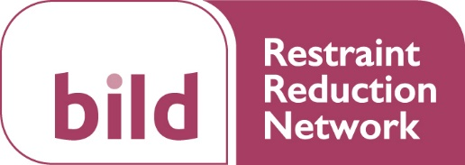

RRN Blog Guidance

Thank you for downloading this Guest Blog Template! We look forward to reading what you have to say.
You can submit your piece in a format most authentic to you, either through writing a blog or using video (a ‘vlog’).
Blogs published on the Restraint Reduction Network website and social media pages aim to:
- Raise awareness of restrictive practices
- Promote a cultural change and best practice with the intention of reducing restrictive practices and improving quality of life
- Provide useful and practical information
- Share personal experiences of reducing restrictive practices
Sharing our collective knowledge and experience can help promote best practice to improve quality of life for those we care for and inspire one another as we face similar real-world challenges.
This blog intends to provide you with an informal space to share your own thoughts and experiences and interact with others who are also passionate about reducing restrictive practices.

Writing a Blog
We recognise that writing a blog can sometimes be daunting, so we want to provide as much support as you require in writing your blog post. We also welcome blogs in video format (vlogs). Below you can find our short guide to writing a blog.
- Plan a structure
  - Introduce what you’re going to write about and why, highlighting the most important points.
  - The middle of your blog should talk about your key points in more detail.
  - Finally, conclude and call your readers to take action.

- Write as if you’re speaking to a friend
  - Whilst it’s beneficial to have a structure to your writing, it does not have to be formal. We want to hear your voice!

- Keep it short and snappy
  - Keep your post between 400-1000 words.

- Consider anonymity and confidentiality
  - If you are writing a piece relating to your own experience, it’s important to consider the confidentiality of anyone you may be referring to. Perhaps you could write the blog with the person or get their permission to be mentioned?

If you would like more guidance, please don’t hesitate to contact Emily Robinson at e.robinson@bild.org.uk.
PLEASE NOTE: Blogs are intended to share best practice and stimulate discussion. They are not designed for advertisement purposes. To this end the blog should not contain website links or any explicit offer to provide training or consultancy.
The RRN administrators will review your blog and offer feedback.
Please email your completed blog and the information below to e.robinson@bild.org.uk

Your name:
Your email address:
Twitter account name:
Blog Title
Key themes

Please write a short biography including where you work (if applicable) and what inspired your blog:

Please write your blog of no more than 1,000 words below:

