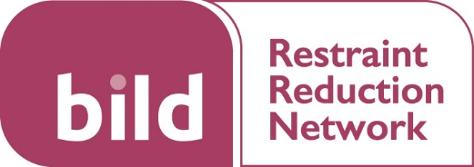

Restraint Reduction Network Conference 2019
Poster application form

We are looking for people to share their work in reducing restrictive practices and present a poster at our annual conference.

There are three categories (please tick which best applies to your work):

Good practice
Innovative practice
Collaboration with experts by experience

Name of lead presenter
Organisation

Contact details
Title of poster

How to submit:
Stage one: Using a maximum of 400 words, please tell us how your poster will cover the areas listed below. Once completed, email this form to conferences@bild.org.uk by 23 September 2019.

• What you did and why?
• How you did it?
• What was the situation before you put the intervention in or carried out the initiative?
• What happened after you put the intervention in?
• Were there any barriers – if so what solutions did you find?
• Was it a success – what factors were important?
• If you were going to do it again would you do it any differently?
• Was there any relevant research in this area that informed this project?

Stage two: We will review all of the proposals and successful applicants will be notified by week commencing 30 September 2019.

Stage three: We are happy to support you with advice concerning the design of your draft poster. The proof must be sent to the Conference Team for final approval week beginning 14 October 2019. If proofs are not submitted, the poster cannot be displayed. Once approved, get printing!

Stage four: Attend conference in November and show your achievements.

Conference participants will vote on an overall winner for the best poster.

Your poster:
•Will be A1 or A2 size
•Will blend text, pictures or symbols, or tables & graphs
•Will contain your contact details – we know posters generate questions & contacts
•The title needs to be short and distinctive. Don’t be dull
•Any text should be readable from about 2 metres distance
•Make use of sub-headings & bullet points

It helps if you can:
•Describe the most astonishingly interesting aspect very briefly
•Use inclusive and non-discriminatory language
•Be available to be asked questions
•Remember that less is best.

Once completed, email this form to conferences@bild.org.uk by 23 September 2019. The conference team will be in touch week commencing 30 September 2019.

